Registration Form for NAWG-16
Monday, 14th to Friday, 18th October, 2019, Yamagata, Japan
Please submit to Russell Alexander (russell@bedrock-geosciences.com) by Friday, 26th April, 2019 if you wish to reserve a room. Please note that we only have a limited number of reserved rooms and, as this is peak season in Yamagata, we cannot guarantee any reservations after this date.
Hotels
I wish to reserve 1. a Japanese Tatami room or 2. a room with twin beds (please indicate your preference) in the Hotel Jurin, Zao Onsen, Yamagata (please see http://www.zao.co.jp/lang/en/jurin/) from 14 – 17th October at a cost of ¥15,000 a night (including breakfast buffet and dinner).
On the Monday evening, dinner will be in the nearby Yamagata Sake Museum where, in addition to a light meal, it will be possible to sample the wonderful local sake, wine and beer (please note that individual participants are responsible for their own costs at this event!).
I also wish to reserve a single room in a hotel (to be confirmed) in central Yamagata for the night of Thursday, 17th October at a cost of ¥10,000. This will include breakfast on Friday, 18th, but not dinner on Thursday, 17th which will be arranged on an ad hoc basis.
Workshop participation
There is no charge for workshop participation, but incidental costs of ¥25,000 cover:
- Coffee and lunch breaks for the duration of the meeting
- Workshop dinner on Wednesday, 16th October
- Meeting to examine the influence of geology on the local wine
Payment details are noted below.
Would you be so kind as to let us know:
- Your name:
- Institution:
- Email address:
- If you would like to submit a paper/poster:
- If so, title of paper/poster:
Please also let us know if you have any dietary preferences.
If you wish to attend only part of the workshop, you are also most welcome. But please let us know in advance so we can arrange lunches etc (which you can pay for directly on the day).
If you would like to participate in the visit to Kunimine Industries Company (KIC) Dobuyama bentonite quarry and outcrops in the vicinity of their Tsukinuno mine (the site of the IBL project – please see www.iblproject.com) on Friday 18th October, please indicate when you reply (BUT PLEASE NOTE – numbers are strictly limited to the first 25 participants to register their interest). A charge of ¥4,000 covers transport and lunch costs for the field trip.
Workshop payment details: Please ensure payment by end September, 2019.

Please pay by direct bank debit
Please pay ¥70,000 (plus ¥10,000 if you require the hotel in Yamagata City and ¥4,000 if you register for the field trip) along with all bank transfer fees, please to:
Bank name: Aargauische Kantonalbank, 5103 Wildegg, Switzerland
Account number: 5828.4324.2008
IBAN: CH53 0076 1582 8432 4200 8
BIC/SWIFT Code: KBAGCH22
Payment description: Fees for the NAWG-16 Workshop

Please include your name and institution and the reference NAWG-16 Workshop. Please also break down the total into (where appropriate):

- Hotel Jurin, Zao Onsen ¥45,000
- Workshop incidental costs ¥25,000
- Hotel in Yamagata City (if required) ¥10,000
- Field trip costs (if required) ¥4,000

Additional information:
Yamagata Prefecture in NE Japan is a beautiful mix of fertile river plains and snow-covered mountain peaks and offers much for the casual or interested traveller. As a first point of contact, please have a look at the local tourist office website (http://data.yamagatakanko.com/english/sightseeing/) which includes a page (http://data.yamagatakanko.com/english/sightseeing/zao.html) on the area where we will hold the workshop.
Although ski-ing is a major draw year-round, the autumn colours and fruit, stunning views and numerous Onsen (traditional Japanese hot springs) offer much to enjoy in and around NAWG-16.

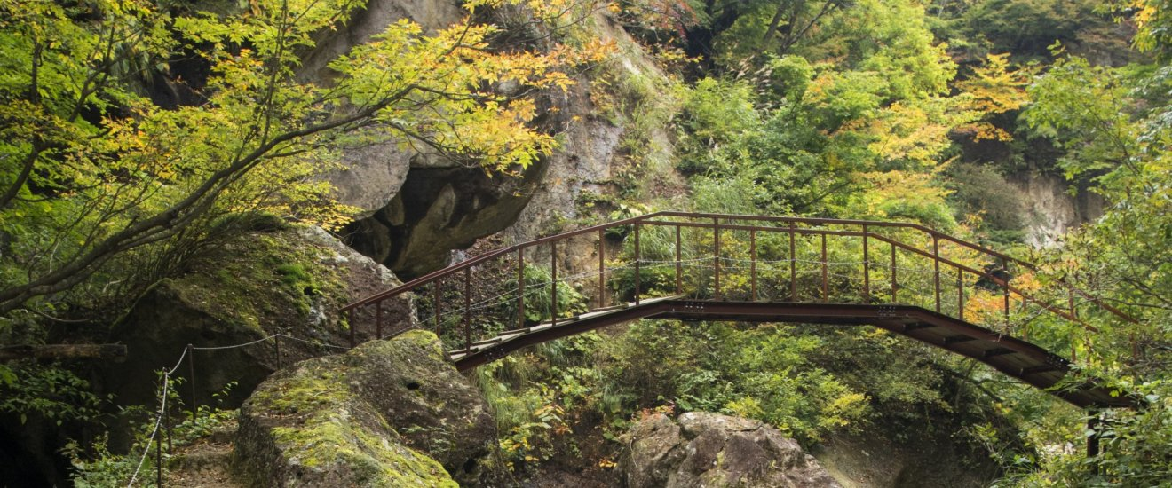
The Omoshiroyama-Yamadera Trail
NAWG-16 will be held with the kind support of NUMO (www.numo.or.jp/en/index.html) and Kunimine Industries Co. Ltd. (https://www.kunimine.co.jp/english/).

